**HTML5**

**Introduction**

HTML5 is the next major revision of the HTML standard superseding HTML 4.01, XHTML 1.0, and XHTML 1.1. HTML5 is a standard for structuring and presenting content on the World Wide Web.

HTML5 is a cooperation between the World Wide Web Consortium (W3C) and the Web Hypertext Application Technology Working Group (WHATWG).

The new standard incorporates features like video playback and drag-and-drop that have been previously dependent on third-party browser plug-ins such as Adobe Flash, Microsoft Silverlight, and Google Gears.

### **HTML5 Example:**

**<!DOCTYPE html>**

**<html>**

**<head>**

**<meta charset="UTF-8">**

**<title>*Title of the document*</title>**

**</head>**

**<body>**

***Content of the document......***

**</body>**

**</html>**

## **New HTML5 API's (Application Programming Interfaces)**

The most interesting new API's in HTML5 are:

* HTML Geolocation
* HTML Drag and Drop
* HTML Local Storage
* HTML Application Cache
* HTML Web Workers
* HTML SSE

**Laying out a Page with HTML5**

**Simple HTML page with Layout Elements**

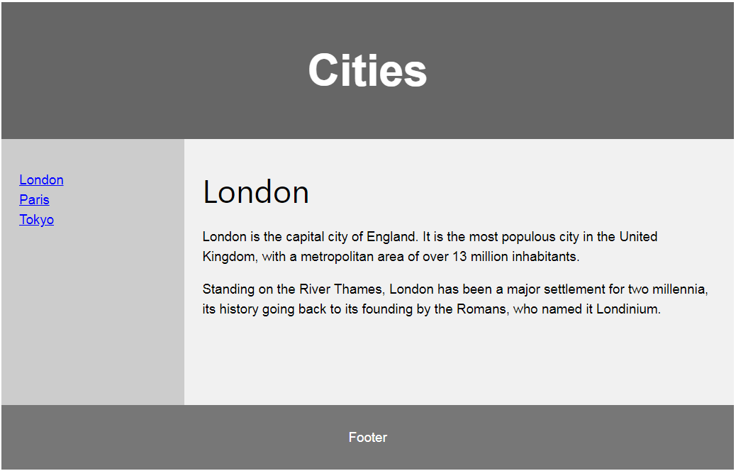

**HTML Layouts**

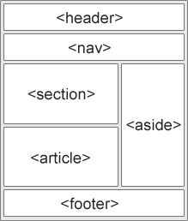

* <header> - Defines a header for a document or a section
* <nav> - Defines a container for navigation links
* <section> - Defines a section in a document
* <article> - Defines an independent self-contained article
* <aside> - Defines content aside from the content (like a sidebar)
* <footer> - Defines a footer for a document or a section
* <details> - Defines additional details
* <summary> - Defines a heading for the <details> element

**Page Structure**

**<!DOCTYPE html>**

**<html>**

**<head>**

**<title>Page Title</title>**

**</head>**

**<body>**

**<h1>My First Heading</h1>**

**<p>My first paragraph.</p>**

**</body>**

**</html>**

**Explanation**

* The <!DOCTYPE html> declaration defines this document to be HTML5
* The <html> element is the root element of an HTML page
* The <head> element contains meta information about the document
* The <title> element specifies a title for the document
* The <body> element contains the visible page content
* The <h1> element defines a large heading
* The <p> element defines a paragraph

## **New HTML5 Tags**

The most interesting new HTML5 elements are:

* New semantic elements like <header>, <footer>, <article>, and <section>.
* New attributes of form elements like number, date, time, calendar, and range.
* New graphic elements: <svg> and <canvas>.
* New multimedia elements: <audio> and <video>.

## **Removed Elements in HTML5**

The following HTML4 elements have been removed in HTML5:

|  |  |
| --- | --- |
| **Removed Element** | **Use Instead** |
| <acronym> | <abbr> |
| <applet> | <object> |
| <basefont> | CSS |
| <big> | CSS |
| <center> | CSS |
| <dir> | <ul> |
| <font> | CSS |
| <frame> |  |
| <frameset> |  |
| <noframes> |  |
| <strike> | CSS, <s>, or <del> |
| <tt> | CSS |

**References**

1. **https://www.w3schools.com/html/html5_intro.asp**
2. **https://www.tutorialspoint.com/html5/html5_overview.htm**